F5 jenkins demo:

Pier-Luc Charbonneau



Last Updated: *Date*

©2014 F5 Networks, Inc. All rights reserved. F5, F5 Networks, and the F5 logo are trademarks of F5 Networks, Inc. in the U.S. and in certain other countries. Other F5 trademarks are identified at f5.com.

Any other products, services, or company names referenced herein may be trademarks of their respective owners with no endorsement or affiliation, express or implied, claimed by F5.

These training materials and documentation are F5 Confidential Information and are subject to the F5 Networks Reseller Agreement. You may not share these training materials and documentation with any third party without the express written permission of F5.

# Table of Contents

Table of Contents 3

Lab 1 – Lab title (heading 1 Style) 4

TASK 1 – Configure the Device Settings on Both BIG-IP Systems (Heading 3 Style) 4

TASK 2 – Configure the Device Group 5

# Lab 1 – Basic setup

This basic setup is required before you can do a demo to your customer

Objective:

* Validate that Jenkins is up and running
* Fork github repository
* Modify Jenkins settings

### TASK 1 – Connect to Jenkins

Connect to Jenkins using username admin and password ru5CkR9O on port 8080 (http://publicIPofLinuxVM:8080

### TASK 2 – Fork github repository

Fork the following repository to your personal github account: https://github.com/plcharbonneau/jenkins_demo

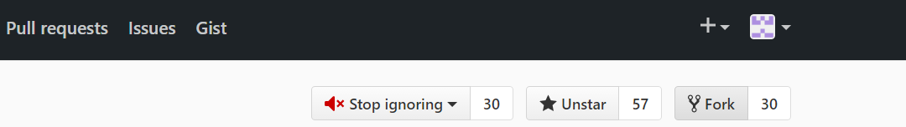

### TASK 4 – Modify Jenkins configuration

Login to Jenkins and click the Deploy_iApp_demo link then configure

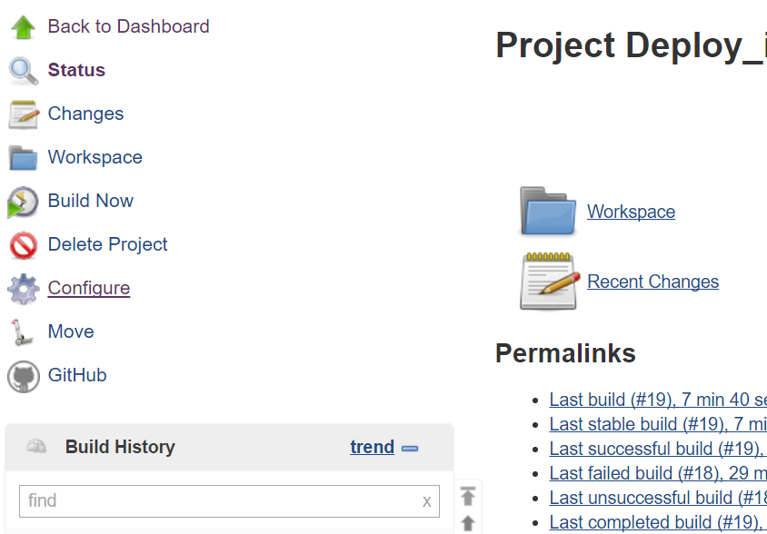

Modify the github link so it uses your github repository

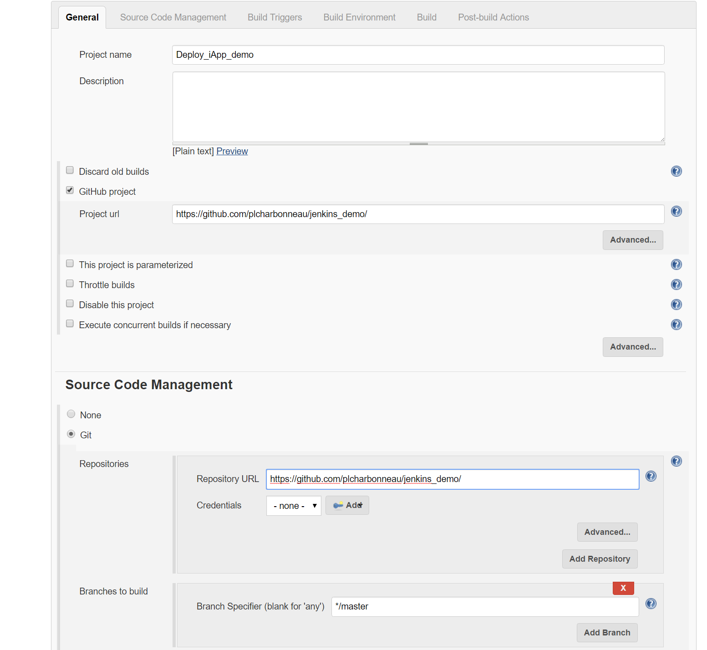

# Lab 2 – Demo

### TASK 1 – Demonstrate that the BigIP configuration is empty

Login to the BigIP public ip address and show the customer that the configuration is empty

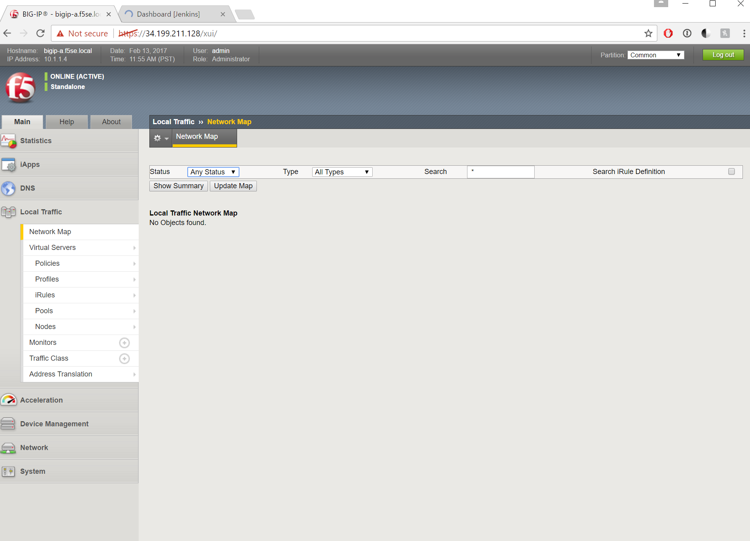

### TASK 2 – Deploy initial config

Go to your github account and show the config files to the customer

We will simulate that the Big-IP has crashed and we need to restore the config. This will also allow us to demonstrate the build capability of Jenkins. Click the clock next to Deploy_iApp_demo in Jenkins

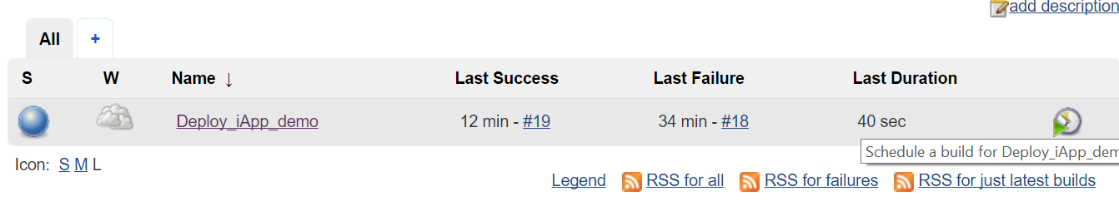

### TASK 3 – Show Big-IP configuration to customer

